1)Write a script using grep command to find the number of words character, words and lines in a file.

First create directory pranavraikar using mkdir command

Then cd pranavraikar

Then touch wordcount

Then navigate to C:\cygwin64\home\student1\pranavraikar from file explorer

Then open the file which is present there wordcount and write the text whose no. of letters is to be counted

Then save it as wordcount.sh

Then go to cgwin terminal and type chmod +x wordcount.sh

Then type the following code on cgwin terminal:

#!/bin/bash

# Prompt the user for the file path

echo "Enter the path to the file:"

read filepath

# Check if the file exists

if [ ! -f "$filepath" ]; then

echo "Error: File not found."

exit 1

fi

# Use grep to count the number of words, characters, and lines in the file

wordcount=$(grep -o '\w\+' "$filepath" | wc -w)

charcount=$(grep -o . "$filepath" | wc -l)

linecount=$(grep -c ^ "$filepath")

# Print the results

echo "Word count: $wordcount"

echo "Character count: $charcount"

echo "Line count: $linecount"

Then type :-

./wordcount.sh

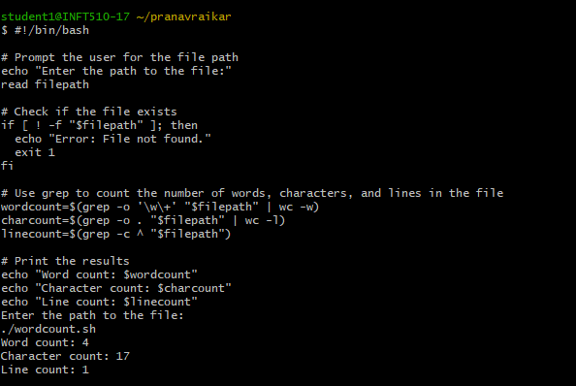

3)Write a script using sed command to replace all occurrences of particular word in a given a file.

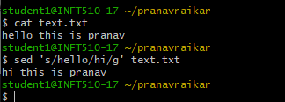

#!/usr/bin/perl

# Initializing an array

@fruits = ('watermelon', 'banana', 'kiwi',

'mango', 'strawberry');

# Sorting array in ascending order

@x = sort { $a cmp $b } @fruits;

# Sorting array in descending order

@y = sort { $b cmp $a } @fruits;

# Printing sorted array

print "Array in ascending order: @x\n";

# Printing sorted array

print "Array in descending order: @y\n";

# Initializing an array

@n = (53, 41, 12, 35, 15, 87, 26, 61);

# Printing Original Array

print "Original Array: @n\n";

# Sorting numbers with use of

# spaceship operator

@x = sort { $a <=> $b } @n;

# Printing sorted array

print "Array after Sorting: @x\n";

B.Execute the following scripts using awk/perl languages.

**For awk first install** 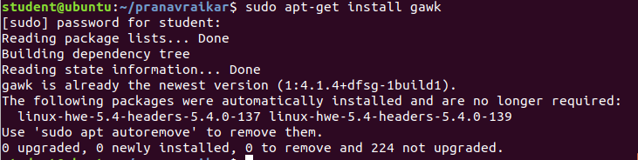

B.2.Write an awk script to develop fibonacci series

**Code(note:once written the code press enter two times then on;ly output will come)**:

{

printf "Enter the number of terms: "

getline terms < "-"

printf ("%s\n",terms)

fib[1] = 1

fib[2] = 1

for (i=3; i<=terms; i++)

fib[i] = fib[i-1]+fib[i-2]

printf("Fibonacci Series Upto %d terms\n",terms)

for(i=1;i<=terms;i++)

printf("%d\t",fib[i])

}

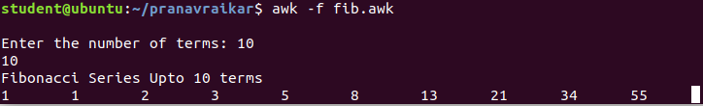

B.1Write an awk script to print all even numbers in a given range.

**CODE(note:once written the code press enter two times then on;ly output will come)**

{

printf "Enter starting number of range: "

getline n1 < "-"

printf "Enter ending number of range: "

getline n2 < "-"

if(n1%2==0) n1=n1

else n1=n1+1

{ for (i = n1; i <= n2; i+=2) print i }

}

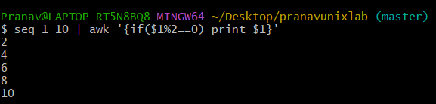

B.3 Write a perl script to sort elements of an array.

Code:

@n = (43, 56, 2, 78, 25, 65, 96, 1);

# Printing Original Array

print "Original Array: @n\n";

# Sorting numbers with use of

# spaceship operator

@x = sort { $a <=> $b } @n;

# Printing sorted array

print "Array after Sorting: @x\n";



B.4 Write a perl script to check a number is prime or not

Code:

#!/usr/bin/perl

print "Enter a number: ";

$n=<>;

$d=0;

if($n==2)

{

print "Prime number.n";

}

else

{

for($c=2;$c<=$n-1;$c++)

{

if($n%$c==0)

{

$d=1;

break;

}

}

if($d==1)

{

print "Number is not prime!\n";

}

else

{

print "Number is prime!\n";

}

}

